**Name: Sahul Kumar Parida Class: 34A Group: 3**

**Subject: AI Applications Lab**

**UID: 20BCS4919**

**Worksheet**

**EXPERIMENT – 5**

**Aim:**

Derive insights from unstructured text using machine learning custom models to classify, extract, and detect sentiments.

**Requirements:**

PC with internet connectivity, Python 3.7

**Expected Outcome:**

**Code:**

**# Sentiment Analysis**

**# import Natural Language Toolkit (NLTK) is a Python package for natural language processing**

**import nltk**

**#for processing textual data. It is used in common natural language processing (NLP) tasks such as part-of-speech tagging, sentiment analysis**

**from textblob import TextBlob**

**#Reading and Writing MS Word Files in Python via Python-Docx Module. First to import text**

**from textblob import Word**

**text = input("Enter the text you want to analyze\n")**

**# Let’s create our first TextBlob**

**obj = TextBlob(text)**

**# Return the setiment of text by returning the values or range -1.0 to 1.0**

**sentiment, subjectivity = obj.sentiment**

**#print(sentiment, subjectivity)**

**print(obj.sentiment)**

**if sentiment == 0:**

**print('The text is neutral')**

**elif sentiment > 0:**

**print('The text is positive')**

**else:**

**print('The text is negative')**

**Output:**

**For positive output**

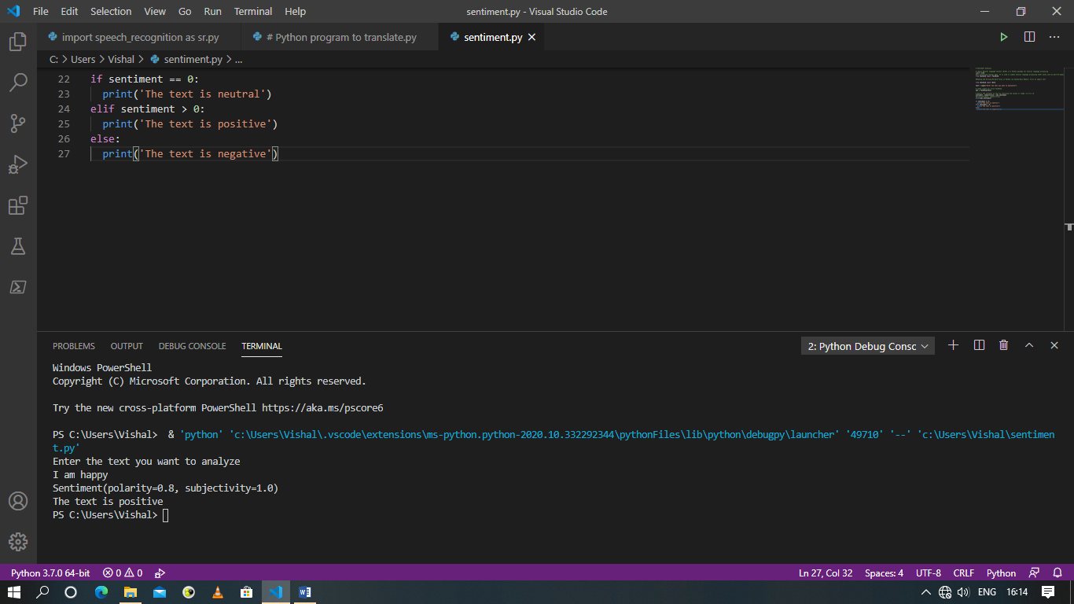

**For negative output**

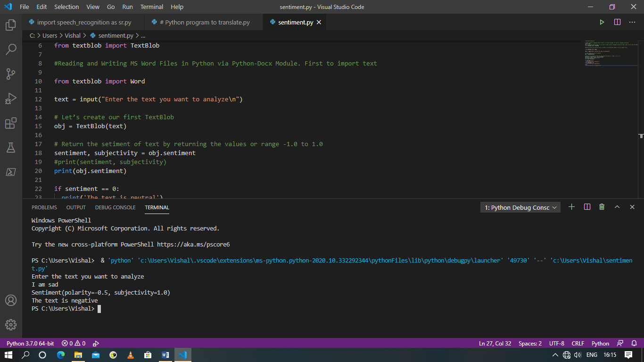

**For neutral output**

